**Practice Sheet**

**Chapter 7 (Relational Schema from ER/EER)**

*Solutions are at the end of the document. SOLVE IT YOURSELF first.

Question 1:

Construct a Relational Schema from the following ER diagram:



Question 2:

Construct a Relational Schema from the following ER diagram:



Question 3:

Construct a Relational Schema from the following ER diagram:



Question 4:

Construct a Relational Schema from the following ER diagram:



Question 5:

Construct a Relational Schema from the following EER diagram. For each of the subclasses/superclasses use any suitable option out of the 4 options.



Question 6:

There are four options for mapping subclasses and superclasses:

8A: separate tables for each subclass and superclass

8B: tables for only subclasses

8C: 1 table with 1 type attribute

8D: 1 table with many type/flag attributes

State which of the above options are not applicable for the following diagrams and explain why. If all 4 options are applicable then simply state “all options are applicable”.











**\*\* Note some questions may have more than one solution.**

**SOLUTIONS:**

Answer 1:

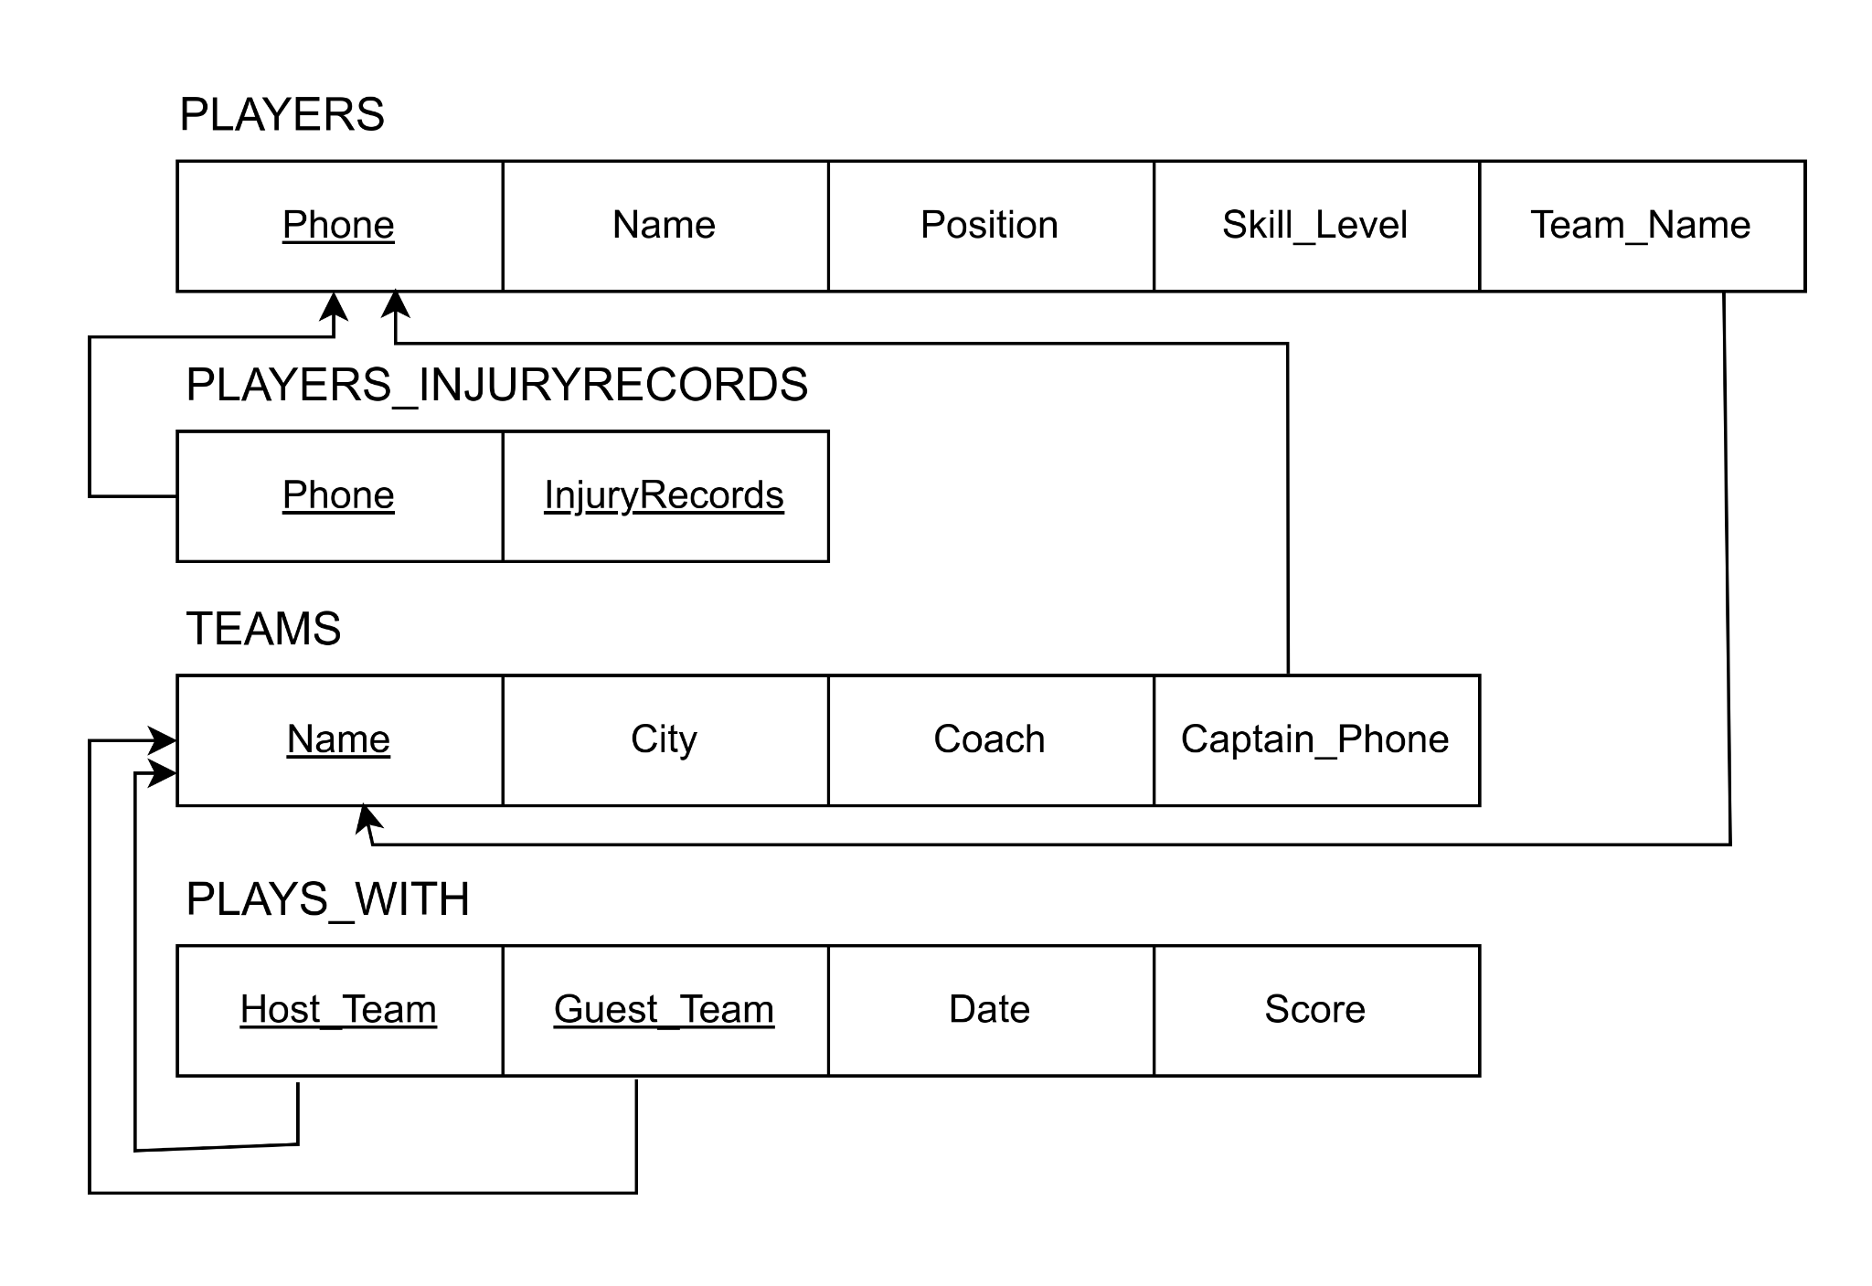

Answer 2:

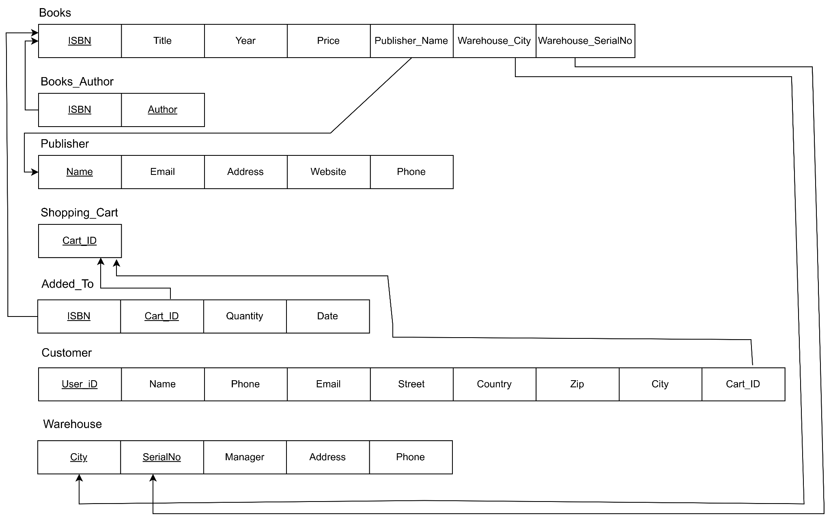

Answer 3:

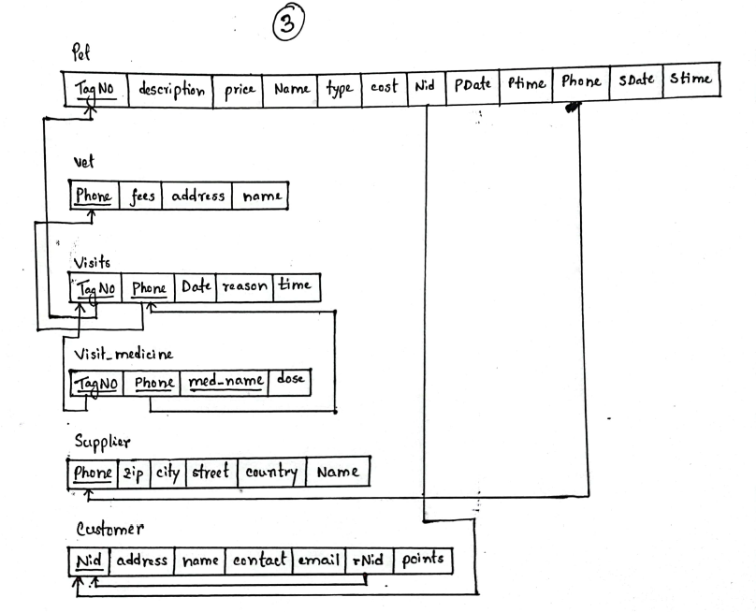

Answer 4:

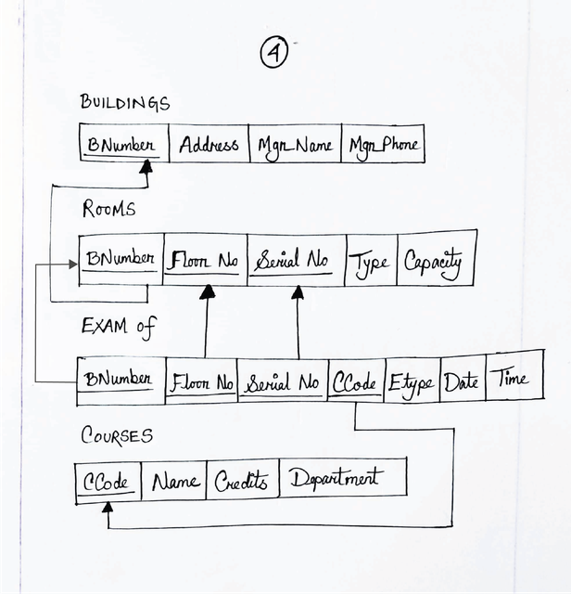

Answer 5:

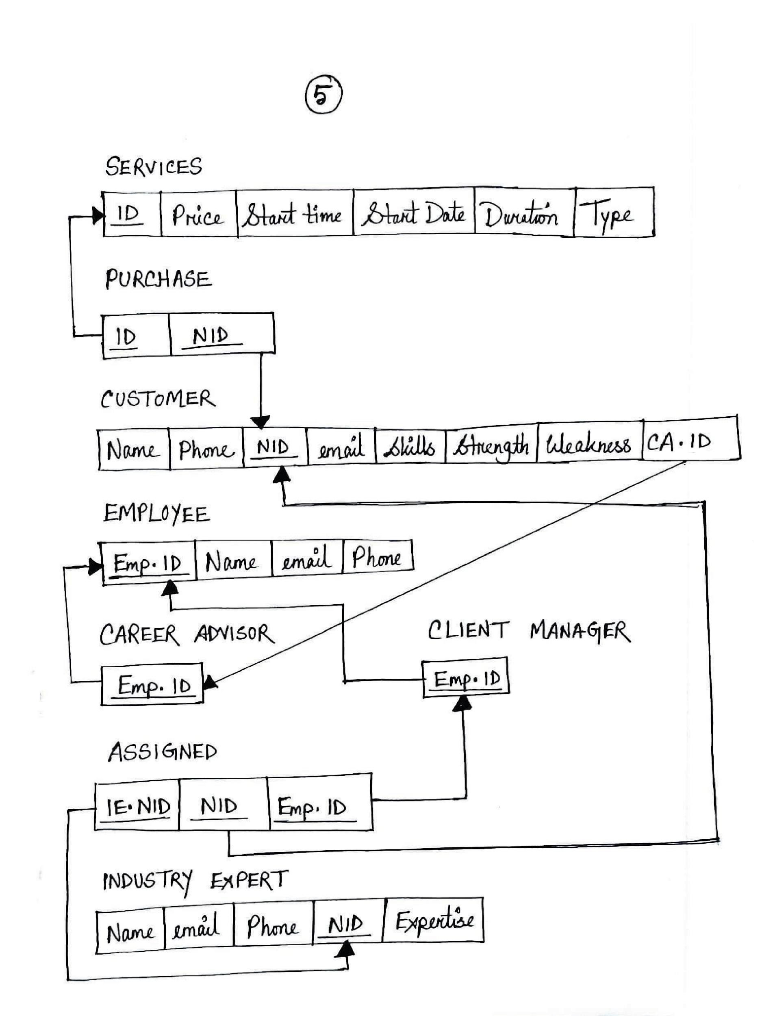

Answer 6:

1. All options are applicable
2. Option 8B is not applicable. The specialization/generalization is partial and 8B is not applicable for partial. Because in 8B we only have tables for subclasses, so if a superclass entity does not belong to any of the subclasses the data for that entity will be lost.
3. Option 8B and 8C not applicable. 8B reason same as above. 8C not applicable for overlapping as only 1 type attribute is not sufficient to store complete information if an entity belongs to multiple subclasses.
4. 8C not applicable. Reason same as above.